Training Fiche E-Seniors

Title | Topic: Information and communication through social media  Module 1. Social media communication for culture and creativity
Training Area | Please select one or more of the following:  Online Security  Cultural and Media Literacy X  Economic Transactions  Personal Data Protection  Digital Identity and online reputation
Keywords (meta tag) | Social media, communication, safety
Provided by | E-Seniors
Language | English
Objectives / goals / learning outcomes
This module aims to develop the knowledge and skills of the users on how to use social media for communication and the promotion of culture and creativity. Senior users will get familiar with the social media tools, cultural resources on social media that enable them to easily navigate and discover cultural and communication opportunities.
Description
The course is arranged into 3 levels: each module is divided into units. The titles of the units give a more detailed idea about the content of the module. The modules are united under the common topical title: Information and communication through social media.
This specific module is built as follows:
Module 1. Social media communication for culture and creativity
Unit 1.1: Facebook
Unit 1.2: WhatsApp
Unit 1.3: Instagram
Unit 1.4: TikTok
Unit 1.5: Twitter
Contents arranged in 3 levels
Topic: Information and communication through social media
Module 1: Social media communication for culture and creativity
Nowadays, social media has multiple functions, aside from online communications social media can be used for receiving and promoting culture and creativity. This module will explain the different characteristic features of social media accounts and raise your awareness of information and communication through social media for culture and creativity.
This module will introduce social media and online communication for culture and creativity. It is divided into two sections: (1) section 1 explains social media accounts and the basics of how to use them; (2) section 2 makes you aware of the online threats and mitigations.
Unit 1.1: Facebook, 2.7 billion active users
Facebook has reached a significant figure of one million users in just 10 months and a figure of one billion in 8 years. The number of new users is estimated at half a million every day.
Facebook is social media, which is also available as a mobile application. It allows users to create a personal profile, upload photo videos, share their opinion, likes, and dislikes of photos, videos, send and receive messages and make calls with or without the video.
Facebook offers several opportunities:
- To connect family and friends
- To advertise and promote business
- To gather like-minded people in groups
- To actively discuss different topics
- To meet new friends
- To find cultural events
- To create cultural and creative events
- To promote one’s cultural and creative work
Section 1.1.1: How to register on Facebook?
When you arrive at the Facebook homepage, you have two options. "Log In" or "Create a new account". By choosing the second option, you will be able to create your Facebook account. For this, you will need to enter personal information such as your name, email address, age, and then the site will ask you to upload a photo to accompany your presentation (optional). From now on, all you have to do is follow the instructions.
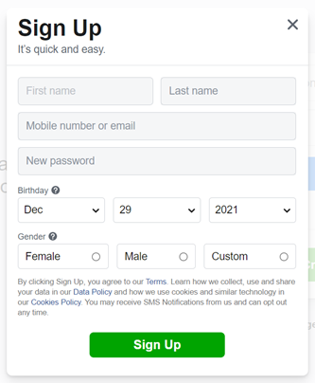

Section 1.1.2: How to add a new friend on Facebook?
Both on the computer and on the mobile application, you will find a search bar at the top of the screen. You can enter the names of people you want to find on Facebook. Once the search is launched, the platform will offer you a list of people with that name or with names close to the one you are looking for. By clicking on the profiles, you can see some information about that person, including the profile picture. If this is the person you were looking for, you can click on the 'Add Friend' button at the top of their profile.
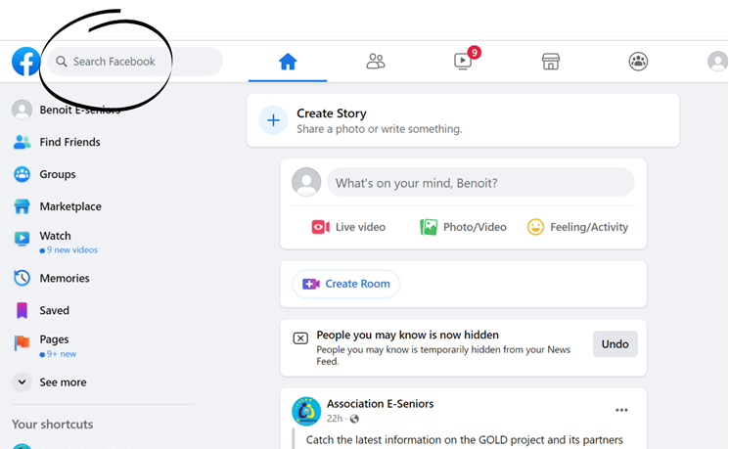
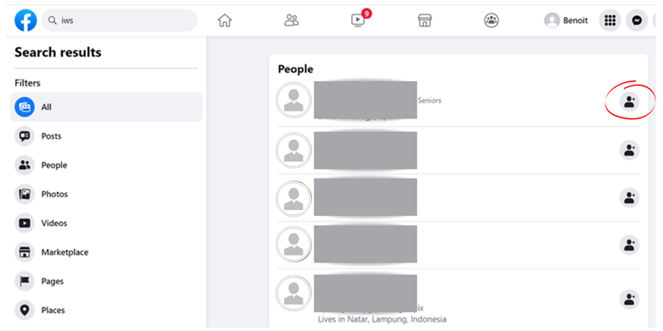
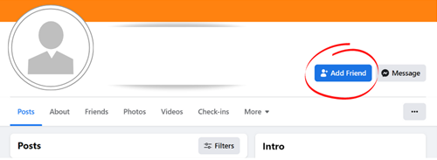
You can also see the notification area (symbolized by a bell) at the top right of the computer screen, or at the bottom right of the smartphone screen, which shows you who has friended you. You can click on 'confirm' or 'Delete Request'.
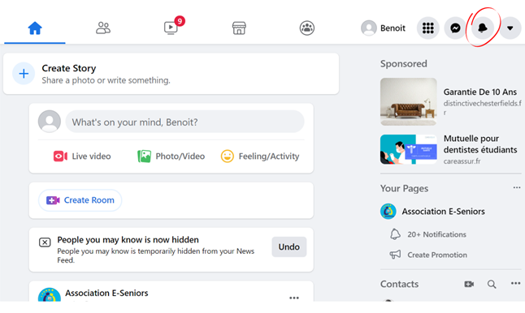
Section 1.1.3: How to join a group on Facebook?
Groups offer a space to exchange on a subject you have in common. To join a group, you need to type in the name of the topic you are interested in, for example, "car fan". You will then be presented with several groups, just like when you were looking for a friend. You have to click on "join the group" on the page of the group that interests you. Be aware that some groups let you in automatically, but others require validation by a group administrator, so there may be a delay before you are accepted into the group.
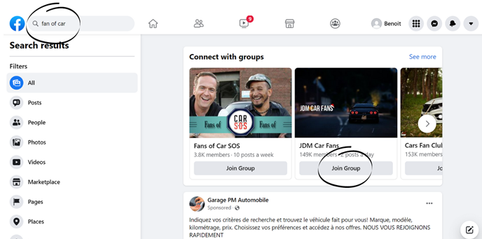
Section 1.1.4: How to write a publication on Facebook?
If you want to write a post or share photos and videos, you need to click on “What’s on your mind?”. You can find it on the main page or on your profile by clicking on your first name at the top right of your computer screen or at the bottom right of your smartphone screen (click on the menu and then at the top of the screen on your name).
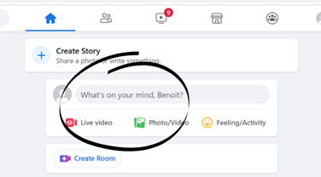
A page will open where you can see a space where it says "What’s on your mind...". Here you can write what you want to share or click on a photo or video if you want to share it. You can do all three at the same time. Then click on "Publish".
You can publish for your friends only, or let the public (people you don't have on your Facebook friend list) see what you share. To choose, before you publish, click on the drop-down menu at the top of the draft publication, it will offer you a choice between "Friends" and "Public".
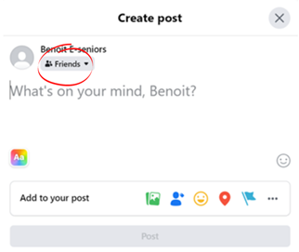
Section 1.1.5: How to send messages on Facebook?
Messenger, which is available on computers and phones, belongs to Facebook. You can open it on your computer directly from Facebook (it opens when you click and “Contact’ or download the App on your phone and register with your Facebook login). It allows people to communicate in pairs or groups and to send photos, videos, audio, and video calls, both in pairs and groups. Once on messenger, you can write the name of the person you want to contact and write a message.
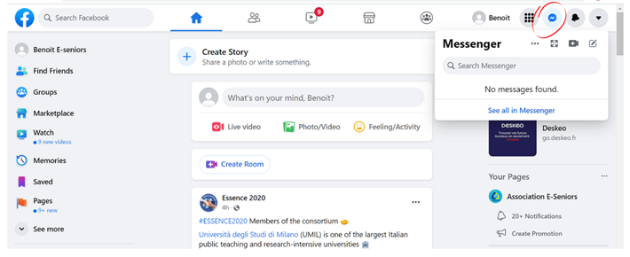
Unit 1.2: WhatsApp, 2 billion
WhatsApp is one of the most used instant messaging services in Europe and the world today. It is also available as a website and mobile application.
It allows two people or larger groups to exchange messages, pictures, videos, or audio messages over the internet connection and between different countries.
It is now possible to chat and make calls with or without video. Many corporate customer services also use this means of communication to simplify and humanize exchanges with consumers.
Section 1.2.1: How to register on WhatsApp?
Once WhatsApp is launched on the computer or opened on the phone, you can register by entering your name and phone number. You cannot register without a phone number. Once you have logged in to the site or application, you can search for your contacts' names in the search bar. If your contacts are registered on WhatsApp as well, you can send them a message.
Section 1.2.2: How to send photos, videos, and audio on WhatsApp?
If you want to send a photo or video, you can click on the photo symbol next to the message space. If you want to send an audio message, you can click on the microphone and keep pressing until your message is finished.
Unit 1.3: Instagram, 1.2 billion
Instagram is a social network specializing in photo and video sharing. Present on the computer as well as on the phone, it is necessary to register, and this registration can also be done with the Facebook account.
The application offers the possibility to share photos or videos instantly and for a period of 24 hours or less.
Section 1.3.1: How to register on Instagram?
Instagram was bought a few years ago by Facebook. When you open the site or app you have three options: Login, Register or you can also log in by entering your Facebook username and password by clicking on "Login with Facebook". If you want to register without a Facebook account then click on "Register" and Instagram will ask you for your name, email or phone number, your username, and a password to create.
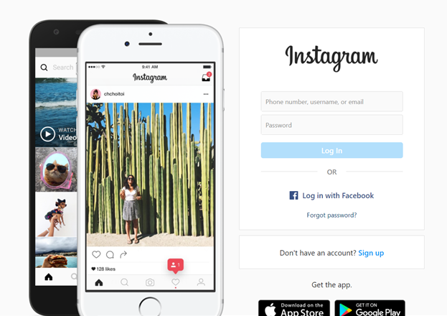
Section 1.3.2: How to “follow” and communicate on Instagram?
As with Facebook, you can search for your friends by typing their names in the search bar at the top of your screen. If you want to see their photos, you have to click on "Follow" and wait for them to accept your request. If they want to see yours as well, they must also click on "Follow" on your profile. To accept them, click on the heart at the top right of the platform and click on "Accept".
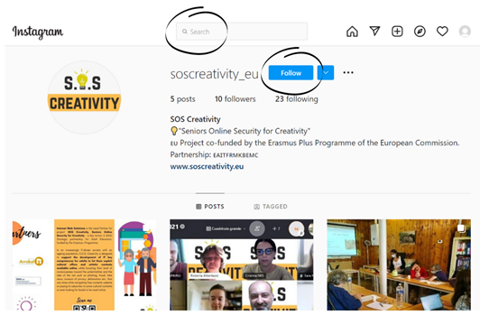
Section 1.3.3: How to modify and post a picture on Instagram?
To post a photo on Instagram, you have two options. Post it for 24 hours as a "story" or share it on your profile indefinitely or until you want to delete it.
To put it in a "story", you can click on the top left circle symbolizing your profile (if you entered a profile photo when you signed up, it is in this circle) and enter your photo or take a photo directly if you are on the mobile application. By scrolling to the right or left, Instagram allows you to change the color filters, so you can modify the photo as you wish.
To post a photo to your profile, click on the "+" symbol at the bottom of the screen and open the photo(s) you want to share. Instagram also offers you the possibility to change the color filters here.
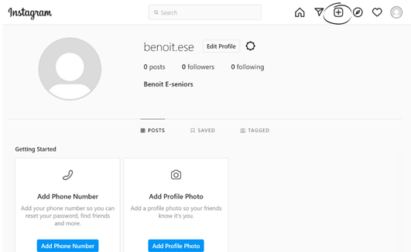
Unit 1.4: TikTok, 689 million
TikTok is a smartphone-only app created in 2016 in China. Its users are mostly between 16 and 24 years old. Registration is done on the app.
The principle of TikTok is sharing of audio videos in 9/16th format. These videos can last a maximum of 15 seconds and can include sound, images, and video sequences.
The particularity of the application is that it relies on the creativity of users and the authenticity of the content. The idea is to publish spontaneously just after making the video.
Section 1.4.1: How to create an account on TikTok?
Download TikTok from Google Play or the App Store, then open the App, tap Profile in the bottom right, and choose a method to sign up
Section 1.4.2: How to create a video on TikTok?
To create a new video, you have to click on the “+” bottom of the screen, upload content from your device Library or use your Camera, add sounds, effects, filters, or other camera tools, then start your video by pressing a button. You can now record your content, make additional edits on the posting page and post your video.
Unit 1.5: Twitter, 326 million
Twitter allows its users to blog using short messages (280 characters maximum, i.e. one or two sentences). What is special about Twitter is that it does not invite readers to comment on the messages posted. The platform is available on computers as well as smartphones, and registration is done directly on it. Twitter is mostly used to share information briefly and quickly. This social network allows people to follow and exchange with all those registered on the platform, including public figures and politicians. Meaning, that if you want to get the information from a specific person, newspaper, or any other account, you need only to click on “follow” and the posts from those you follow will automatically appear on your wall.
Section 1.5.1: How to create an account on Twitter?
Open a Twitter Page or App, click on the button that says “Sign Up Now”. Begin the sign-up information by providing your username, date of birth, and your choice of an email account or phone number. Click on the button that says "Create Account." A verification code will be sent to your email address or phone number. Enter the verification code once you receive it. Create a password. It will need to be at least six characters. Add your picture. At the top of the settings page, you will see a "photo" tab. Click this and add a photo of you.
Section 1.5.2: How to follow people on Twitter?
To follow people and see what they post, type their name in the search bar and click on "Follow".
Section 1.5.3: How to post on Twitter?
To post a tweet, select the New Tweet button near the top of the screen. The tweet box will appear. You can type what you want to post (280 characters maximum), then select Tweet. The tweet will be shared publicly, along with anyone who follows you on Twitter. It'll also appear at the top of your timeline.

These different sites and applications allow different forms of communication. The TikTok application is essentially a recreational and creative application, also very young. It should be avoided if you want to communicate with other people in a simple way.
Facebook and Twitter allow us to follow the news of the people with whom we have connected. Indeed, these platforms allow us to see the messages and photos left by our 'contacts' to all their own contacts.
For simple and direct messages, the best tools are WhatsApp and Messenger. They allow us to communicate directly with the recipients or groups of recipients we choose. The advantage of Messenger is that it allows us to communicate directly with the contacts we already follow on Facebook. As for WhatsApp, it only requires a phone number to connect and is particularly popular in Europe today.
Instagram has a recreational role as well, it allows us to follow the news of the people we follow, but it also gives us the possibility to exchange messages with these same recipients. Today, almost all website has buttons redirecting to Twitter, Facebook, Instagram. By clicking the share button and any of the logos of social media apps, you can easily share the information on your personal account.

Contents in bullet points
- Mostly used social media networks: Facebook, Instagram, Twitter; Tiktok
- You can discover events, photos, exhibitions, etc. on these social media channels
- You can use social media for finding cultural resources and promote your own creative work, you can be inspired, or you can inspire your friends, etc;
- You can avoid social media threats and risks by following recommendations and advice stipulated in this training module
5 glossary entries
Social media: a social network is a service that brings together various people to create an exchange on a particular subject or not
Communication online: Online communication is a form of communication that consists of using the various existing channels on the Internet to communicate and interact online in order to relay a message adapted to a target audience.
Social media safety: Social media security refers to all the measures that the user should take to avoid risks, scams, and attacks on their personal account
Social media profile: Social media profiles are a description of the social characteristics of individuals that identify them on social media sites such as Facebook or Instagram. Profiles describe a number of characteristics of individuals, such as interests, professional affiliations, status, recent activity, and geographical location. Profiles are a person's digital DNA and also display information that helps to understand the type and strength of a person's relationships with others.
Bibliography and Further References
https://understandthesocialmedia.com/
https://wtccentralpa.org/wp-content/uploads/2013/01/socialmedia-2.pdf
https://www.thebalancesmb.com/what-is-social-media-2890301
Five multiple-choice self-assessment questions | 1) What cannot be done, on Instagram?  - Add photos  - Follow our friends  - Join a group  Correct: C  2) WhatsApp does not allow video calls.  - True  - False  Correct: A  3) There is a character limit on each Twitter post  - True  - False  Correct: A
Related Material
Related PPT
Reference Link
Video in YouTube format (if any) | What is Social Media? In Simple English:  https://www.youtube.com/watch?v=jQ8J3IHhn8A  Amazing mind reader reveals his 'gift': https://www.youtube.com/watch?v=F7pYHN9iC9I

