- Training Fiche
- Società Cooperativa Fuori dal Sommerso

Title | Platforms promoting culture and how they work
Training Area | Please select one or more of the following:  Cultural and Media Literacy x  Economic Transactions  Online Security  Personal Data Protection  Digital Identity and online reputation
Keywords (meta tag) | Streaming, Free Movies, on-demand, Platforms, Media libraries
Provided by | Società Cooperativa Fuori Dal Sommerso
Language | EN
Objectives / goals / learning outcomes
- Understand what “streaming” is and how it works;
- Learn about the difference between streaming and live- streaming;
- Know which the main streaming platforms are and about the opportunities they offer to enjoy different cultural contents;
- Learn about the accessibility of the streaming platforms in terms of eventual subscription fees;
- Know about a special case of streaming platform delivering high -quality programmes which are free of charge and come in 6 different languages;

Description (for listing purposes)
In this training, we will clarify the meaning of streaming and introduce you to the world of online platforms for culture (cinema, music, theatre, etc.).
Contents arranged in 3 levels
Introduction
In this module we are going to introduce you in the world of the On-line Streaming and to the numerous opportunities it offers to enjoy in a convenient, simple and safe way of a wide range of cultural and multimedia contents, like movies, series, shows, concerts, art performances, audiobooks and much more. You are going to understand what streaming is, how it works and how you can access to the streaming platforms and their contents, and lastly which are some of the most popular and interesting streaming platforms.
- Module name : Platforms promoting culture and how they work
  - Unit 1.1 What is streaming?
Just like cinema and radio were once ousted by the television as the primary medium of mass communication and entertainment, streaming has transformed the World Wide Web in the present digital era we live in. Today, audio and video are considered the most natural means to communicate, as opposed to conventional text-based standards. Streaming has been considered by many as an alternate delivery channel to conventional television and radio. Before going any further, let’s get one thing out of the way: what is streaming?
Streaming is the method of data transmission used when someone watches a video on the Internet. It is a way to deliver a video file a little bit at a time, often from a remote storage location. By transmitting a few seconds of the file at a time over the internet, client devices do not have to download the entire video before starting to play it.
Streaming refers to any media content – live or recorded – delivered to computers and mobile devices via the internet and played back in real-time Podcasts, webcasts, movies, TV shows, and music videos are common forms of streaming content.
Difference between Live streaming and streaming
Streaming is the process of sending or receiving data (mostly audio and video files) over computer networks among mobile devices via the Internet. It simply is a means to display multimedia content that can be processed as a steady, continuous flow. Streaming media is delivered by a provider and received by the users in real-time. The term “stream” refers to the technique of delivering and receiving media, rather than the media itself. Streaming media has dramatically revolutionized the ways in which media is transmitted and consumed. Most of us or it would suffice to say, almost all of us, engage with streaming media on a daily basis via streaming media platforms such as Netflix, YouTube, Spotify, Prime Video, Mubi, Vimeo, and more. Today, the Internet pervades our lives and at the center of it is streaming media.
Live streaming is when the streamed video is sent over the Internet in real-time , without first being recorded and stored. Today, TV broadcasts, video game streams, and social media videos can all be live-streamed.
Live- streaming is the broadcast of an event over the internet as it happens. Award shows, sports, boxing matches, video games, and special one-time events are the most popular types of live- streaming with an ever-growing menu of topics.
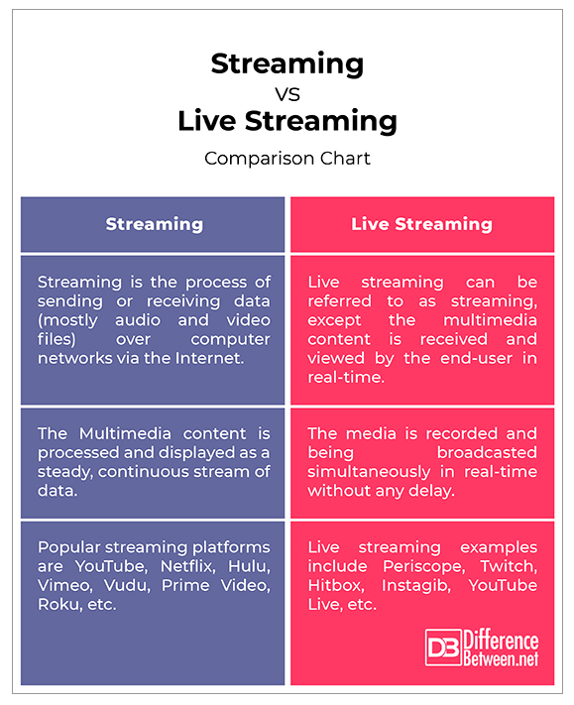
To recap, live- streaming is basically the same as streaming, except in live- streaming, the multimedia content is received and viewed by the end-user in real-time without any significant delay or time gap meaning the media is played as it arrives. In regular streaming, digital media is processed and displayed as a steady, continuous stream of data through streaming media platforms such as Netflix, YouTube, Vimeo, Roku, Hulu, and more. With regular streaming, the media file is a pre-recorded, static file that’s being downloaded onto the system that the media server has access to. Live- streaming, on the other hand presents a whole different set of challenges compared to video on demand. The media is simply intended for single-purpose transmission and playback over the Internet in real-time.
Unit 1.2 The main streaming platforms
Many older people rely on the many channels of television when they are looking for recreation and entertainment. Few of those who use the Internet really take advantage of the many more advanced entertainment offerings, such as streaming platforms, online podcasts or media libraries. The Internet offers a huge range of possibilities, even free of charge, which can be of interest to the elderly. Thanks to the many videos, audiobooks , TV series, documentaries or radio programs available, you can keep busy with your favorite programs and access them at any time.
Here are some entertainment channels for the elderly that can also be accessed for free:
- Media libraries of public broadcasters (In Italy Rai, Mediaset, Dplay, etc.): Here you will find most of the films, series and documentaries shown on TV. The programs listed online are available at any time. If you have a Smart TV, i.e. a television that can connect to the Internet, then you can access this content directly from your TV.
- YouTube and Vimeo: the online video platform: Any user connected to the Internet can upload a video to YouTube. Here you will find, in addition to clips of television programs, also videos of private users on many topics such as sports, information or even explanatory videos (tutorials).
- Radio stations and online podcasts: You can listen to a radio station online at any time. For example, on radio.it you can filter radio stations based on a specific genre or theme or listen to radios in your region. There are also paid programs such as Spotify, Apple Music or Deezer, where you can listen to music and choose from many musical genres.
- Streaming platforms: Even in these streaming platforms, it is possible to access and watch numerous films and series at any time, just like in the media libraries. However, these platforms are usually subject to a subscription but also offer a lot more choice. In Europe, the ranking of the most used platforms sees Netflix in the first place, and its 67 million subscribers, followed by Amazon Prime Video and Disney +.
Each of the aforementioned platforms boasts vast catalogues, allowing all subscribers to have access to a huge amount of content of all kinds.
It is important to underline that these services are fee -based services.
But, how can we use multiple services without having to pay all the full price?
In this regard, there is a service called TogetherPrice.com. With this service, you can share your subscription with other people, even strangers. The really handy thing is that no one will be forced to share their data, let alone depend on others for payment, as each will have his own staff.
To find the various cultural services online you can have a look to our repository https://www.soscreativity.eu/repositories.php?page=4
Unit 1.3 A case study: ARTE – The European culture channel
ARTE (an acronym for Association Relative à la Télévisione Européenne) is a franco-german TV channel, created back in 1992 with the aim of promoting unity and understanding amongst Europeans. Indeed, the mission of the channel is to “make culture a living link between European citizens”. The programmes of ARTE are committed to issues that are important to European citizens: combating inequality, whether social, cultural, economic, geographical, gender, or disability-related , and promoting sustainable development. ARTE is almost entirely funded through German and French public fundings which guarantee its independence and press freedom. Thanks to a co-funding of the European Union, it was possible to offer the subtitling service so that wide selections of programmes are now available with subtitles in 6 European languages (English , G erman, F rench, S panish, I talian and P olish), which allows to 70% of Europeans to access the contents in their mother language. ARTE features original documentaries with wide- ranging topics, like science, health, environment, technology, discovery, history, and food, and they can be considered as the core production of the channel. But it also offers many contemporary and awarded European movies, dramas and series, news -related programmes, music, and performing arts. All the programmes are for free.
User experience and Accessibility
Besides the TV broadcast which can only be watched in Germany and France (unless you have a satellite service), ARTE is available on -demand in streaming mode through multiple devices:
- from computers through the website https://www.arte.tv/en/
- downloading the ARTE App from the app store in your mobile device or into your smart TV if you have one;
- from the ARTE social media pages;
The daily programmes can be viewed “on- demand”: from 5 in the morning you can watch the day’s programmes in the order you prefer, at any time.
The user can create a personal account for free which allows creating a watching list, save the history of the viewed programmes, and receive recommendations based on personal preferences. The website language can be altered in the top-right corner with the little downward arrow. Once you’ve selected your language, all programmes available in the chosen language will appear. Same for the app: Tap on the little gear icon in the top-right corner of your ARTE app and select the language you wish. You can also change the language on a programme directly, by clicking on the little speech-bubble icon at the bottom-right of each video. Unfortunately, due to broadcast restrictions, not all programmes are available in all language versions and in all territories. Lastly, the programmes are accessible for deaf or hard of hearing and for blind or visually impaired people thanks to the audio descriptions and the subtitles.
Conclusions
From what we have said so far, we can conclude that the on-line streaming is no doubts one of the most entertaining and exciting opportunity that the Internet offers to access high quality multimedia contents. The fact that the streaming contents can be viewed “on-demand” makes it particularly convenient, as we can decide when to watch any content according to our time and needs. Also, many streaming contents are available for free, although most of the time a it is required to register to the platform offering the content.
Contents in bullet points (Summing Up)
• What streaming is and which opportunities do streaming platforms offer to enjoy a wide selection of contents like documentaries, movies, series, podcasts, music, art performances;
• The difference between streaming and live -streaming and the concept of watching streaming contents on-demand;
• A list of the main- streaming platforms;
ARTE: A deeper look into a high -quality European culture TV channel, which offers all its programmes for free in 6 different languages through the streaming platform https://www.arte.tv/en/
5 glossary entries
1) Streaming: The technology of transmitting audio and video files in a continuous flow over a wired or wireless internet connection.
2) Podcast: is an episodic series of spoken-word digital audio files that a user can download to a personal device for easy listening. Streaming applications and podcasting services provide a convenient and integrated way to manage a personal consumption queue across many podcast sources and playback devices.
3) Binge Watching: the practice of watching multiple episodes of a television programme in rapid succession, typically by means of DVDs or digital streaming.
4) Smart TV: Also known as an Internet TV, a Smart TV is any TV that can provide additional programs through internet connectivity. It's like having a computer built into your TV.
5) On- Demand: On-Demand (also referred to as Video On Demand or VOD) allows the viewer to watch the selected movie or TV content whenever at his or her schedule’s convenience. With On-Demand, viewers can pause, play, fast-forward, rewind, and re-watch the show On-Demand as much as they would like.
Five multiple-choice self-assessment questions | 1) What is a streaming platform?  - It’s a technology used to deliver content by downloading it into computers or other mobile devices.  - It’s a way of transmitting and receiving data (video or audio) over the Internet.  - It’s a TV channel.  Correct Answer : B  2) What is a live streaming?  - It is when the streamed content is sent over the internet in real time, but viewed by the user at a later moment.  - It’s a type of streaming platform.  - It is when the streamed content is sent over the Internet in real time, without first being recorded or stored and viewed by the user right away.  Correct Answer : C  3) From which devices can you watch a streaming content?  - From a Smart TV  - From a computer and from mobile phones  - From all the above mentioned devices.  Correct Answer : C  4) Do you need an internet connection to access streaming contents?  - Yes  - No  Correct Answer : A  5) What is a streaming platform?  - It’s a satellite broadcast.  - A It’s a internet browser.  - It is a website, application or software that allows you to enjoy a wide selection of on-demand multimedia content for free or with a subscription fee.  Correct Answer : C
Related Material
Related PPT
Video in YouTube format (if any) | ARTE.TV Documentary  https://www.youtube.com/c/ARTEDocumentary
References and more information on the topic
What is live streaming, How live streaming works, https://www.cloudflare.com/learning/video/what-is-live-streaming/
Streaming, https://www.verizon.com/info/definitions/streaming/
Difference between Streaming and live streaming, http://www.differencebetween.net/technology/difference-between-streaming-and-live-streaming/
Hobby Online, Come tenersi occupati nella terza età,
https://www.c-and-a.com/it/it/shop/hobby-online-anziani

Related Link | ARTE.TV  https://www.arte.tv/en/

